Question 14.1
A network administrator wants the syslog server to filter incoming messages into different files based on their importance. Which filtering criteria must be used?
A. message body
B. process ID
C. level
D. facility

Answer: C
Explanation
Syslog levels indicate the severity or importance of log messages. According to this figure then the best answer should be “level”:
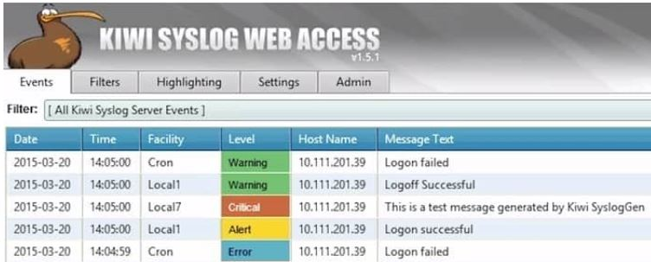
A syslog message has the following format:
seq no:timestamp%FACILTY-SEVERITY-MNEMONIC: message text
Each portion of a syslog message has a specific meaning:
+ Seq no: a sequence number only if the service sequence-numbers global configuration command is configured
+ Timestamp: Date and time of the message or event. This information appears only if the service timestamps global configuration command is configured.
+ FACILITY: This tells the protocol, module, or process that generated the message. Some examples are SYS for the operating system, IF for an interface…
+ SEVERITY: A number from 0 to 7 designating the importance of the action reported.
Note: The facility value is used to determine which process of the machine created the message. Since the Syslog protocol was originally written on BSD Unix, the Facilities reflect the names of UNIX processes and daemons -> Answer D is not correct.
Question 14.2
What is a characteristic of frame switching?
A. populates the ARP table with the egress port
B. drops received MAC addresses not listed in the address table
C. stores and forwards frames in a buffer and uses error checking
D. rewrites the source and destination MAC address

Answer: C
Explanation
Frame switching is one of a few important switching concepts that describe how a switch operates.
2.1.b Frame switching
LAN switches are characterized by the forwarding method that they support, such as a store-and-forward switch, cut-through switch, or fragment-free switch.
Store-and-forward switches store the entire frame in internal memory and check the frame for errors before forwarding the frame to its destination.
…
Reference: https://www.econfigs.com/ccna-2-1-describe-and-verify-switching-concepts-mac-learning-and-aging-frame-switching-frame-flooding-mac-address-table/
Question 14.3
What is represented by the word “R20” within this JSON schema?
1 [
2 {"firewall": "FW12", "port":"e0/23"},
3 {"router": "R20", "port":"te5/5"},
4 {"switch": "SW25", "port":"ge1/36"},
5 ]
A. value
B. array
C. key
D. object

Answer: A
Explanation
JSON syntax structure:
+ A key/value pair consists of a key (must be a string in double quotation marks ""), followed by a colon :, followed by a value. For example: “name”:”John”
Therefore in this question, “router” is the key while “R20” is the value.
Question 14.4
Refer to the exhibit.
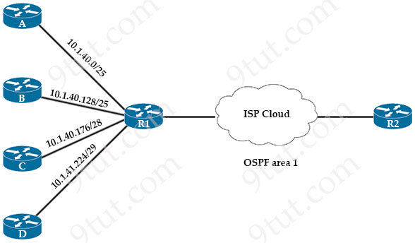
Router R1 receives static routing updates from routers A, B, C. and D. The network engineer wants R1 to advertise static routes in OSPF area 1. Which summary address must be advertised in OSPF?
A. 10.1.40.0/25
B. 10.1.40.0/24
C. 10.1.41.0/25
D. 10.1.40.0/23

Answer: D
Explanation
Maybe there is a typo in this question for the subnet of router C as 10.1.40.176/28 belongs to 10.1.40.128/25 subnet of router B. Therefore we guess in fact the subnet of router C is 10.1.41.176/28.
In four options only the subnet mask of /23 can cover all of these subnets so answer D is the best choice.
Question 14.5
Refer to the exhibit.
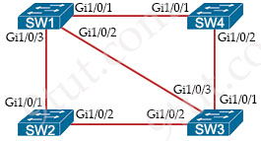
Which switch becomes the root bridge?
A. SW 1
Bridge Priority – 28672
mac-address 00:10:a1:51:57:51
B. SW 2
Bridge Priority – 28672
mac-address 00:10:a1:82:03:94
C. SW3
Bridge Priority – 12288
mac-address 00:10:a1:95:2b:77
D. SW4
Bridge Priority – 12288
mac-address 00:10:a1:03:42:e8

Answer: D
Explanation
The switch with lowest bridge priority will be chosen the root bridge. If many switches have the same bridge priority then the lowest MAC address would be chosen.
Question 14.6
Which two values or settings must be entered when configuring a new WLAN in the Cisco Wireless LAN Controller GUI? (Choose two)
A. management interface settings
B. QoS settings
C. ip address of one or more access points
D. SSID
E. Profile name

Answer: D E
Question 14.7
Drag and drop the characteristic from the left onto the IPv6 address type on the right.
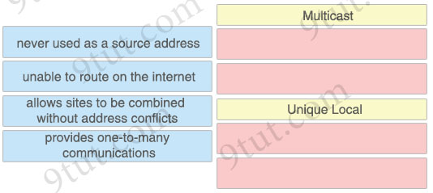

Answer:
Multicast
+ never used as a source address
+ provides one-to-many communications
Unique Local
+ unable to route on the internet
+ allows sites to be combined without address conflicts
Question 14.8
Refer to the exhibit.
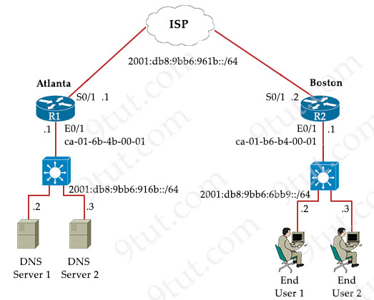
The IPv6 address for the LAN segment on router R2 must be configured using the EUI-64 format. When configured which ipv6 address is produced by the router?
A. 2001:db8:9bb6:6bb9:C801:B6FF:FEB4:1
B. 2001:db8:9bb6:6bb9:C001:6BFE:FF01:1
C. 2001:db8:9bb6:6bb9:C081:B6FF:FF4B:1
D. 2001:db8:9bb6:6bb9:4626:109F:FE56:1

Answer: A
Explanation
The EUI-64 format must have “FF:FE” in the middle of the MAC address of E0/1 interface of R1 -> Only answer A is correct.
Question 14.9
Drag and drop the management connection types from the left onto the definitions on the right.
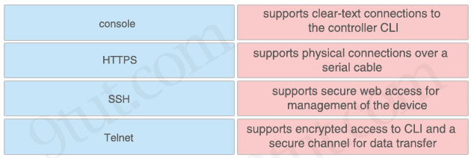

Answer:
+ supports clear-text connections to the controller CLI: Telnet
+ supports physical connections over a serial cable: console
+ supports secure web access for management of the device: HTTPS
+ supports encrypted access to CLI and a secure channel for data transfer: SSH
Question 14.10
What must be considered before deploying virtual machines?
A. location of the virtual machines within the data center environment
B. whether to leverage VSM to map multiple virtual processors to two or more virtual machines
C. resource limitations, such as the number of CPU cores and the amount of memory
D. support for physical peripherals, such as monitors, keyboards, and mice

Answer: C
Question 14.11
What is the role of the root port in a switched network?
A. It replaces the designated port when the designated port fails
B. It is the best path to the root from a nonroot switch
C. It replaces the designated port when the root port fails
D. It is administratively disabled until a failover occurs

Answer: B
Explanation
Root port is the port that is closest to the root bridge, which means it is the port that receiving the lowest-cost BPDU from the root. Every non-root bridge must have a root port. All root ports are placed in forwarding state.
Question 14.12
Which type of encryption does WPA1 use for data protection?
A. AES
B. TKIP
C. PEAP
D. EAP

Answer: B
Explanation
By default, WPA1 uses Temporal Key Integrity Protocol (TKIP) and message integrity check (MIC) for data protection.
Question 14.13
Refer to the exhibit.
R_1# show ip route
.....
D 192.168.20.0/26 [90/24513456] via 10.10.10.1
R 192.168.20.0/24 [120/5] via 10.10.10.2
0 192.168.0.0/19 [110/219414] via 10.10.10.13
B 192.168.0.0/16 is variably subnetted, 4 subnets,4 masks
D 192.168.20.0/27 [90/4123710] via 10.10.10.12
D 192.168.20.0/25 [90/14464211] via 10.10.10.11
S* 0.0.0.0/0 [1/0] via 10.10.10.14
Packets are flowing from 192.168.10.1 to the destination at IP address 192.168.20.75. Which next hop will the router select for the packet?
A. 10.10.10.1
B. 10.10.10.11
C. 10.10.10.12
D. 10.10.10.14

Answer: B
Explanation
The destination at IP address 192.168.20.75 does not belong to 192.168.20.0/26 or 192.168.20.0/27. It only belongs to 192.168.20.0/25 (increment: 128) so the next hop router will be 10.10.10.11.
Question 14.14
What happens when a switch receives a frame with a destination MAC address that recently aged out?
A. The switch references the MAC address aging table for historical addresses on the port that received the frame
B. The switch floods the frame to all ports in all VLANs except the port that received the frame
C. The switch drops the frame and learns the destination MAC address again from the port that received the frame
D. The switch floods the frame to all ports in the VLAN except the port that received the frame

Answer: D
Question 14.15
What is used to identify spurious DHCP servers?
A. DHCPREQUEST
B. DHCPDISCOVER
C. DHCPACK
D. DHCPOFFER

Answer: B
Explanation
You can detect spurious DHCP servers by sending dummy DHCPDISCOVER packets out to all of the DHCP servers so that a response is sent back to the switch. We can also prevent spurious DHCP servers by using DHCP Snooping feature on switches.
Question 14.16
Refer to the exhibit.
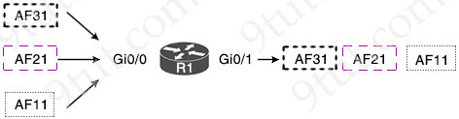
Which per-hop QoS behavior is R1 applying to incoming packets?
A. queuing
B. marking
C. shaping
D. policing

Answer: A
Explanation
Forwarding Per-Hop Behavior (PHB) is a mechanism used in Quality of Service (QoS) to control the behavior of packets as they traverse a network. The following are some of the key components of PHB:
1. Classification: This is the process of categorizing network traffic into different groups based on specific criteria such as IP address, protocol, port, or application type.
2. Marking: This is the process of setting a marking or tag on a packet, indicating its priority level or class. Marking is typically done at the edge of the network and is used by the network devices to make QoS decisions.
3. Queuing: This is the process of holding packets in a queue and scheduling their transmission based on their priority. Queuing algorithms, such as Weighted Fair Queuing (WFQ), ensure that high-priority packets are transmitted before low-priority packets.
4. Congestion: This occurs when the network becomes congested and there is not enough bandwidth to handle all the traffic. PHB includes mechanisms, such as Random Early Detection (RED), to help manage congestion by discarding low-priority packets before high-priority packets.
5. Policing: This is the process of monitoring network traffic and enforcing specified traffic rate limits. If a packet exceeds the specified rate limit, it can be discarded or marked with a lower priority.
6. Shaping: This is the process of controlling the rate at which packets are transmitted into the network. This helps to ensure that the network does not become congested and that all packets are transmitted in a timely manner.
Reference: https://www.tutorialsweb.com/networking/cisco/IP-services/IP-services-10.htm
In this question, answer “marking” is not correct as the packets have been classified into different forwarding classes already. Answers “shaping” and “policing” seems to be incorrect. Only answer “queuing” is the best choice left.
Question 14.17
What is the temporary state that switch ports always enter immediately after the boot process when Rapid PVST+ is used?
A. discarding
B. listening
C. forwarding
D. learning

Answer: A
Explanation
At first, a switch port starts in a discarding state, a discarding port does not forward any frames nor does it learn MAC addresses, and it also listens for BPDUs. Backup and alternate ports remain discarding.
In RSTP if a port is elected as a Root port or Designated port, the transition will directly take place from a discarding state to a learning state. Hence, RSTP doesn’t need a listening state. A learning port adds MAC addresses into the Content addressable memory table; However, it can not forward frames.
In the next phase, a learning port transitions into a forwarding state. A forwarding port is completely functional i.e., it learns MAC addresses, sends and listens for BPDUs, and forwards frames.
Reference: https://www.geeksforgeeks.org/rapid-spanning-tree-protocol/
Question 14.18
A wireless access point is needed and must meet these requirements:
* “zero-touch” deployed and managed by a WLC
* process only real-time MAC functionality
* used in a split-MAC architecture.
Which access point type must be used?
A. autonomous
B. lightweight
C. mesh
D. cloud-based

Answer: B
Explanation
+ Lightweight: The term ‘lightweight’ refers to the fact that these devices cannot work independently. A Cisco lightweight AP (LAP) has to join a Wireless LAN Controller (WLC) to function. LAP and WLC communicate with each other via a logical pair of CAPWAP tunnels.
Note: The LAP-WLC division of labor is known as a split-MAC architecture, where the normal MAC operations are pulled apart into two distinct locations. This occurs for every LAP in the network; each one must boot and bind itself to a WLC to support wireless clients. The WLC becomes the central hub that supports a number of LAPs scattered about in the network.
Reference: https://www.oreilly.com/library/view/ccna-wireless-640-722/9780133445725/ch09lev3sec1.html
Question 14.19
Which components are contained within a virtual machine?
A. physical resources, including the NIC, RAM, disk, and CPU
B. configuration files backed by physical resources from the Hypervisor
C. applications running on the Hypervisor
D. processes running on the Hypervisor and a guest OS

Answer: B
Explanation
A Virtual Machine (VM) is a compute resource that uses software instead of a physical computer to run programs and deploy apps.
A virtual machine needs four core resources: CPU, memory, network, and storage (disk). These resources are granted to the virtual machine through the configuration of the virtual hardware.
Note: Answer A is not correct as a VM does not contain physical resources. A VM only uses a virtual NIC, a portion of physical RAM and virtual CPU (vCPU).
Question 14.20
Refer to the exhibit.
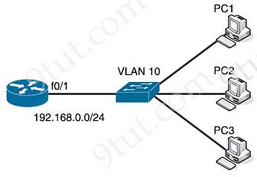
An engineer assigns IP addressing to the current VLAN with three PCs. The configuration must also account for the expansion of 30 additional VLANs using the same Class C subnet for subnetting and host count. Which command set fulfills the request while reserving address space for the expected growth?
A. Switch(config)#interface vlan 10
Switch(config-if)#ip address 192.168.0.1 255.255.255.252
B. Switch(config)#interface vlan 10
Switch(config-if)#ip address 192.168.0.1 255.255.255.248
C. Switch(config)#interface vlan 10
Switch(config-if)#ip address 192.168.0.1 255.255.255.0
D. Switch(config)#interface vlan 10
Switch(config-if)#ip address 192.168.0.1 255.255.255.128

Answer: B
Explanation
We need 30 additional VLANs so we need 30 subnets. Therefore we need to borrow 5 bits (25 = 32 > 30) from 192.168.0.0/24 -> The new subnet masks should be /29 (/24 + 5) or 255.255.255.248.
Question 14.21
Which interface IP address serves as the tunnel source for CAPWAP packets from the WLC to an AP?
A. service
B. trunk
C. AP-manager
D. virtual AP connection

Answer: C
Explanation
The AP-manager IP address is used as the tunnel source for CAPWAP packets from the controller to the access point and as the destination for CAPWAP packets from the access point to the controller.
Reference: https://www.cisco.com/c/en/us/td/docs/wireless/controller/5700/software/release/3e/consolidated/configuration-guide/b_multi_3e_5700_cg/b_multi_3e_5700_cg_chapter_011010.pdf
Question 14.22
What does a switch search for in the CAM table when forwarding a frame?
A. source MAC address and aging time
B. destination MAC address and flush time
C. source MAC address and source port
D. destination MAC address and destination port

Answer: D
Question 14.23
Which type of hypervisor operates without an underlying OS to host virtual machines?
A. Type 1
B. Type 2
C. Type 3
D. Type 12

Answer: A
Explanation
There are two types of hypervisors: type 1 and type 2 hypervisor.
In type 1 hypervisor (or native hypervisor), the hypervisor is installed directly on the physical server. Then instances of an operating system (OS) are installed on the hypervisor. Type 1 hypervisor has direct access to the hardware resources. Therefore they are more efficient than hosted architectures. Some examples of type 1 hypervisor are VMware vSphere/ESXi, Oracle VM Server, KVM and Microsoft Hyper-V.
In contrast to type 1 hypervisor, a type 2 hypervisor (or hosted hypervisor) runs on top of an operating system and not the physical hardware directly. A big advantage of Type 2 hypervisors is that management console software is not required. Examples of type 2 hypervisor are VMware Workstation (which can run on Windows, Mac and Linux) or Microsoft Virtual PC (only runs on Windows).
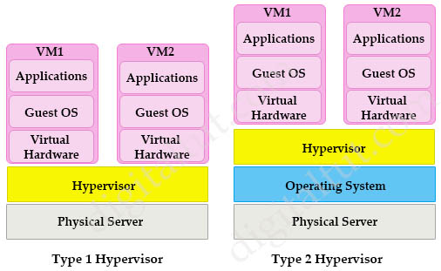
Question 14.24
Refer to the exhibit.
Connection-specific DNS Suffix . :
Description .................: Intel(R) Ethernet Connection (2) I218-V
Physical Address.............: D0-50-99-47-A9-7F
DHCP Enabled.................: Yes
Autoconfiguration Enabled....: Yes
Link-local IPv6 Address .....: fe80::8809:9772:c583:6bl8%15(Preferred)
IPv4 Address.................: 192.168.69.132(Preferred)
Subnet Mask .................: 255.255.255.0
Lease Obtained...............: Thursday, January 21, 2021 11:10:46 PM
Lease Expires ...............: Wednesday, February 3, 2021 11:27:29 AM
Default Gateway..............: 192.168.69.1
DHCP Server .................: 192.168.69.1
DHCPv6 IAID .................: 231755929
DHCPv6 Client DUID...........: 00-01-00-01-26-D7-BB-3F-D0-50-99-47-A9-7F
DNS Servers .................: 192.168.69.1
NetBIOS over Tcpip...........: Enabled
What does the host do when using the IPv4 Preferred function?
A. It continues to use a statically assigned IPv4 address
B. It forces the DNS server to provide the same IPv4 address at each renewal
C. It requests the same IPv4 address when it renews its lease with the DHCP server
D. It prefers a pool of addresses when renewing the IPv4 host IP address

Answer: C
Explanation
“Preferred” is what your client will ask the DHCP server for when it gets/renews the lease.
Question 14.25
Drag and drop the characteristic from the left onto the IPv6 address type on the right.
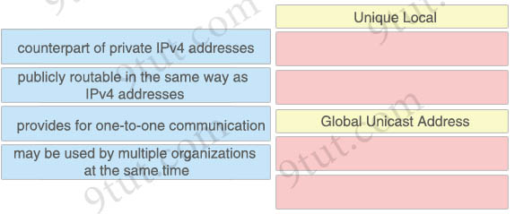

Answer:
Unique Local
+ counterpart of private IPv4 addresses
+ may be used by multiple organizations at the same time
Global Unicast Address
+ publicly routable in the same way as IPv4 addresses
+ provides for one-to-one communication
Question 14.26
How does MAC learning function?
A. restricts ports to a maximum of 10 dynamically-learned addresses
B. increases security on the management VLAN
C. associates the MAC address with the port on which it is received
D. drops received MAC addresses not listed in the address table

Answer: C
Question 14.27
What are two capabilities provided by VRRP within a LAN network? (Choose two)
A. load sharing
B. bandwidth optimization
C. dynamic routing updates
D. redundancy
E. granular QoS

Answer: A D
Explanation
Virtual Router Redundancy Protocol (VRRP) is an open standard protocol, which is used to provide redundancy in a network -> Answer D is correct.
In load balancing mode, a VRRP group maps its virtual IP address to multiple virtual MAC addresses: one virtual MAC address for each group member. The master uses these virtual MAC addresses of the member routers to respond to IPv4 ARP requests or IPv6 ND requests from hosts. Therefore, every router in this VRRP group can forward traffic and traffic from hosts is distributed across the VRRP group members -> Answer A is correct.
Question 14.28
Drag and drop the characteristic from the left onto the device type on the right. Not all characteristics are used.
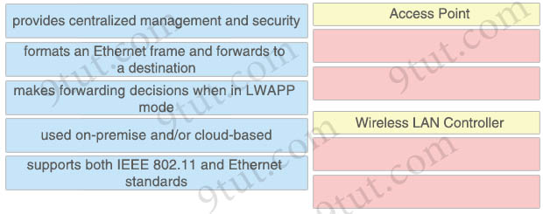

Answer:
Access Point
+ formats an Ethernet frame and forwards to a destination
+ supports both IEEE 802.11 and Ethernet standards
Wireless LAN Controller
+ provides centralized management and security
+ makes forwarding decisions when in LWAPP mode
Explanation
Lightweight (LWAPP) Mode: Centrally managed by a Wireless LAN Controller or WLC. The WLC can be a physical appliance for large networks or it can be a virtual machine. Sometimes it is embedded into ISR router or a switch such as Cat3850. Cisco calls it “Converged Access”. The “brain” is at the controller level. Think of the AP is simply an Ethernet extension transmitting data frames between wire and wireless. The controller tells the AP who to transmit to and what to transmit and all added on security, OoS and so on.
Reference: https://www.speaknetworks.com/converting-cisco-wireless-access-point-lightweight-mode-autonomous-mode-vice-versa/
An access point connects to a wired router, switch, or hub via an Ethernet cable, and projects a WiFi signal to a designated area so it supports Ethernet standards too.
Question 14.29
Refer to the exhibit.
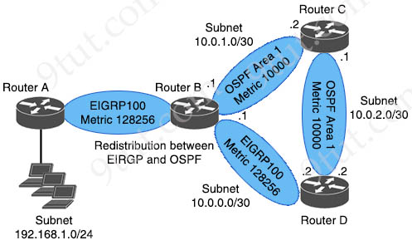
A network engineer executes the show ip route command on router D. What is the next hop to network 192.168.1.0/24 and why?
A. The next hop is 10.0.2.1 because it is a link-state routing protocol
B. The next hop is 10.0.0.1 because it has a better administrative distance
C. The next hop is 10.0.2.1 because it uses distance vector routing
D. The next hop is 10.0.0.1 because it has a higher metric

Answer: B
Explanation
We don’t care about metric in this question as Administrative Distances (AD) are compared first.
Router D receives two paths for networks 192.168.1.0/24:
+ From Router C: OSPF External route with AD of 110
+ From Router B: EIGRP route with AD of 90
-> Route from Router B wins with lower AD.
Question 14.30
Drag and drop the statement about AAA services from the left to the corresponding AAA services on the right.
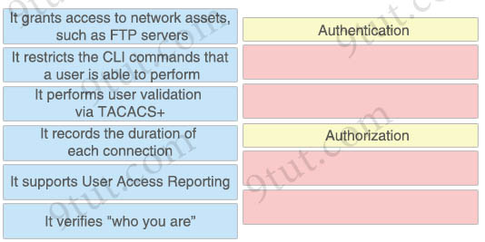

Answer:
Authentication
+ It performs user validation via TACACS+
+ It verifies “who you are”
Authorization
+ It grants access to network assets, such as FTP servers
+ It restricts the CLI commands that a user is able to perform
Question 14.31
Refer to the exhibit.
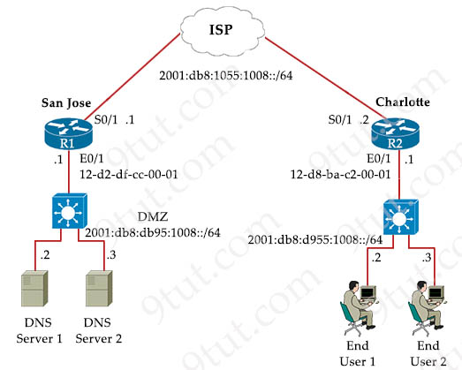
The IPv6 address for the LAN segment on router R2 must be configured using the EUI-64 format. When configured which ipv6 address is produced by the router?
A. 2001:db8:d955:1008:1030:ABFF:FECC:1
B. 2001:db8:d955:1008:12D8:BAFE:FF01:1
C. 2001:db8:d955:1008:10D8:BAFF:FEC2:1
D. 2001:db8:d955:1008:4635:278F:FE95:1

Answer: C
Explanation
The EUI-64 format must have “FF:FE” in the middle of the MAC address of E0/1 interface of R2 and “C2:1” (means “C2:0001”) at the end -> Only answer C is correct.
Question 14.32
Which interface is used to send traffic to the destination network?
O 10.18.75.113/27 [110/6906] via G0/6
O 10.18.75.113/27 [110/23018] via G0/3
R 10.18.75.113/27 [120/16] via G0/16
R 10.18.75.113/27 [120/14] via G0/23
A. G0/6
B. G0/3
C. G0/16
D. G0/23

Answer: A
Explanation
The first entry has lowest AD (110) and lowest metric (6906) so it is the best route and will be installed into the routing table.
Question 14.33
Which AP mode is used for capturing wireless traffic and forwarding that traffic to a PC that is running a packet analyzer?
A. monitor
B. sniffer
C. bridge
D. rouge detector

Answer: B
Explanation
+ Sniffer mode: run as a sniffer and captures and forwards all the packets on a particular channel to a remote machine where you can use protocol analysis tool (Wireshark, Airopeek, etc) to review the packets and diagnose issues. Strictly used for troubleshooting purposes.
Note: Rogue detector mode: monitor for rogue APs. It does not handle data at all.
Question 14.34
What is a characteristic of a Layer 2 switch?
A. provides a single broadcast domain for all connected devices
B. tracks the number of active TCP connections
C. offers one collision domain for all connected devices
D. makes forwarding decisions based on MAC addresses

Answer: D
Explanation
In this question there are two correct answers which are answer A and answer D. But answer D is better as it is an important characteristic of a Layer 2 switch.
Question 14.35
What is a characteristic of frame switching?
A. inspects and drops frames from unknown destinations
B. floods unknown destinations to all ports except the receiving port
C. forwards frames to a neighbor port using CDP
D. protects against denial of service attacks

Answer: B
Question 14.36
Which interface is used for out-of-band management on a WLC?
A. dynamic
B. management
C. service port
D. virtual

Answer: C
Question 14.37
Which interface condition is occurring in this output?
R30# show interface fa0/0
FastEthernet0/0 is up, line protocol is up
Hardware is DEC21140, address is ca02.7788.0000 (bia ca02.7788.0000)
Description: madrid_subnet
Internet address is 10.32.102.2/30
MTU 1500 bytes, BW 100000 Kbit/sec, DLY 100 usec,
reliability 255/255, txload 1/255, rxload 1/255
Encapsulation ARPA, loopback not set
Keepalive set (60 sec)
Half-duplex, 100 Mb/s, 100BaseTX/FX
ARP type: ARPA, ARP Timeout 04:00:00
Last input 00:00:01, output 00:00:00, output hang never
Last clearing of "show interface" counters 00:00:18
Input queue: 0/300/0/0 (size/max/drops/flushes); Total output drops: 0
Queueing strategy: fifo
Output queue: 0/300 (size/max)
30 second input rate 0 bits/sec, 0 packets/sec
30 second output rate 0 bits/sec, 0 packets/sec
7331 packets input, 7101162 bytes
Received 267 broadcasts (0 IP multicasts)
35 runts, 0 giants, 0 throttles
0 input errors, 0 CRC, 0 frame, 0 overrun, 0 ignored
0 watchdog
0 input packets with dribble condition detected
3927 packets output, 1440403 bytes, 0 underruns
0 output errors, 480 collisions, 0 interface resets
0 unknown protocol drops
0 babbles, 0 late collision, 0 deferred
0 lost carrier, 0 no carrier
0 output buffer failures, 0 output buffers swapped out
A. bad NIC
B. broadcast storm
C. queueing
D. duplex mismatch

Answer: D
Explanation
This interface gets high collision (480 collisions) so one end may be set to “Half-duplex”.
Question 14.38
Which interface is used to send traffic to the destination network?
D 10.47.114.119/29 [90/6451] via F0/2
D 10.47.114.119/29 [90/52201] via F0/20
R 10.47.114.119/29 [120/9] via F0/12
R 10.47.114.119/29 [120/10] via F0/10
A. F0/2
B. F0/20
C. F0/12
D. F0/10

Answer: A
Question 14.39
Why would an administrator choose to implement an automated network management solution?
A. to enable ‘box by box” configuration and deployment
B. to limit recurrent management costs
C. to reduce operational costs
D. to support simpler password policies

Answer: C
Explanation
Why automate your network?
One of the biggest issues for network managers is the growth of IT costs for network operations. The growth of data and devices is starting to outpace IT capabilities, making manual approaches nearly impossible. Yet up to 95 percent of network changes are performed manually, resulting in operational costs 2 to 3 times higher than the cost of the network. Increased IT automation, centrally and remotely managed, is essential for businesses to keep pace in the digital world.
Reference: https://www.cisco.com/c/en/us/solutions/automation/network-automation.html
-> Automated network management solution helps reduce the operational costs.
Question 14.40
Refer to the exhibit.
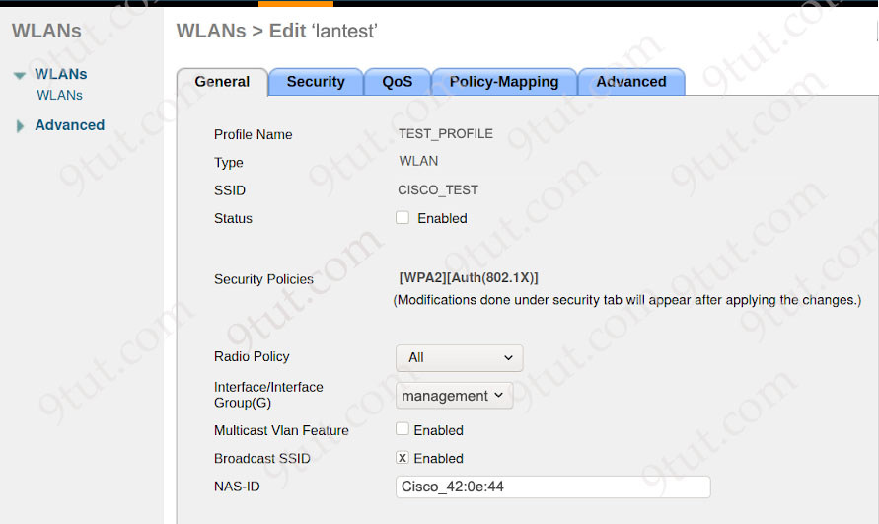
A Cisco WLC administrator is creating a new wireless network with enhanced SSID security. The new network must operate at 2.4 GHz with 54 Mbps of throughput. Which set of tasks must the administrator perform to complete the configuration?
A. Check the Broadcast SSID check box and set the Radio Policy to 802.11a only.
B. Uncheck the Broadcast SSID check box and set the Radio Policy to 802.11a/g only.
C. Check the Broadcast SSID check box and set the Radio Policy to 802.11g only.
D. Uncheck the Broadcast SSID check box and set the Radio Policy to 802.11g only.

Answer: D
Explanation
“operate at 2.4 GHz with 54 Mbps of throughput” -> Only 804.11g is suitable.
“enhanced SSID security” so we should not broadcast SSID so that no one can see the SSID.
Wireless Standards
IEEE Standard | Frequency/Medium | Speed | Transmission Range
802.11 | 2.4GHz RF | 1 to 2Mbps | 20 feet indoors.
802.11a | 5GHz | Up to 54Mbps | 25 to 75 feet indoors; range can be affected by building materials.
802.11b | 2.4GHz | Up to 11Mbps | Up to 150 feet indoors; range can be affected by building materials.
802.11g | 2.4GHz | Up to 54Mbps | Up to 150 feet indoors; range can be affected by building materials.
802.11n | 2.4GHz/5GHz | Up to 600Mbps | 175+ feet indoors; range can be affected by building materials.
Question 14.41
Under which condition is TCP preferred over UDP?
A. TCP is used when data reliability is critical, and UDP is used when missing packets are acceptable
B. UDP is used when low latency is optimal, and TCP is used when latency is tolerable
C. UDP is used when data is highly interactive, and TCP is used when data is time-sensitive
D. TCP is used when dropped data is more acceptable, and UDP is used when data is accepted out-of-order

Answer: A
Question 14.42
Which device protects an internal network from the Internet?
A. firewall
B. Layer 2 switch
C. router
D. access point

Answer: A
Question 14.43
An engineer must update the configuration on two PCs in two different subnets to communicate locally with each other. One PC is configured with IP address 192.168.25.128/25 and the other with 192.168.25.100/25. Which network mask must the engineer configure on both PCs to enable the communication?
A. 255.255.255.248
B. 255.255.255.0
C. 255.255.255.252
D. 255.255.255.224

Answer: B
Explanation
This question wants to merge two above IP addresses into one subnet so that two PCs can communicate locally so only answer B can do it. With other subnet masks, IP address 192.168.25.128 becomes network address so it cannot be assigned to a host.
Question 14.44
Which type of protocol is VRRP?
A. uses dynamic IP address assignment
B. uses a destination IP address 224.0.0.102 for router-to-router communication
C. uses Cisco-proprietary First Hop Redundancy Protocol
D. allows two or more routers to act as a default gateway

Answer: D
Explanation
VRRP uses multicast address 224.0.0.18 for router-to-router communication -> Answer B is not correct.
VRRP is IETF RFC 3768 standard -> Answer C is not correct.
VRRP does not use dynamic IP address assignment. We can configure any virtual IP address -> Answer A is not correct.
Question 14.45
How are RFC 1918 IP addresses used in a network?
A. They are used instead of public addresses for increased security.
B. They are used by internet service providers to route over the internet.
C. They are used to access the internet from the internal network without conversion.
D. They are used with NAT to preserve public IPv4 addresses.

Answer: D
Explanation
The RFC 1918 is Address Allocation for Private Internets, which reserves IP addresses for private and internal use. These addresses can be used for networks that do not need to connect to the Internet.
RFC 1918 addresses are used to conserve IPv4 addresses from depletion by reserving ranges of IPv4 addresses for the devices which are inside a private network so answer D is the best choice (and it is better than answer A).
Question 14.46
A network architect is deciding whether to implement Cisco autonomous access points or lightweight access points. Which fact about firmware updates must the architect consider?
A. Unlike autonomous access points, lightweight access points require a WLC to implement remote firmware updates.
B. Unlike lightweight access points, autonomous access points can recover automatically from a corrupt firmware update
C. Unlike lightweight access points, which require redundant WLCs to support firmware upgrades, autonomous access points require only one WLC.
D. Unlike autonomous access points, lightweight access points store a complete copy of the current firmware for backup.

Answer: A
Explanation
Cisco Access Points (APs) can operate in one of two modes: autonomous or lightweight
+ Autonomous: self-sufficient and standalone. Used for small wireless networks. Each autonomous AP must be configured with a management IP address so that it can be remotely accessed using Telnet, SSH, or a web interface. Each AP must be individually managed and maintained unless you use a management platform such as Cisco DNA Center.
+ Lightweight: The term ‘lightweight’ refers to the fact that these devices cannot work independently. A Cisco lightweight AP (LAP) has to join a Wireless LAN Controller (WLC) to function. LAP and WLC communicate with each other via a logical pair of CAPWAP tunnels.
Question 14.47
A DHCP pool has been created with the name CONTROL. The pool uses the next to last usable IP address as the default gateway for the DHCP clients. The server is located at 172.16.32.15. What is the next step in the process for clients on the 192.168.52.0/24 subnet to reach the DHCP server?
A. ip forward-protocol udp 137
B. ip default-network 192.168.52.253
C. ip default-gateway 192.168.52.253
D. ip helper-address 172.16.32.15

Answer: D
Explanation
We see the server is located in a different subnet from the clients so we need to configure the “ip helper-address 172.16.32.15” on the router so that DHCP messages can reach the server.
Question 14.48
Refer to the exhibit.
R1#
Gateway of last resort is 10.56.0.1 to network 0.0.0.0

S* 0.0.0.0/0 [1/0] via 10.56.0.1
10.0.0.0/8 is variably subnetted, 2 subnets, 2 masks
C 10.56.0.0/16 is directly connected, Null0
C 10.56.0.0/26 is directly connected, Vlan58
C 10.56.0.0/17 is directly connected, Vlan59
C 10.56.0.0/24 is directly connected, Vlan60
When router R1 receives a packet with destination IP address 10.56.0.62, through which interface does it route the packet?
A. Vlan59
B. Vlan60
C. Null0
D. Vlan58

Answer: D
Question 14.49
Refer to the exhibit.
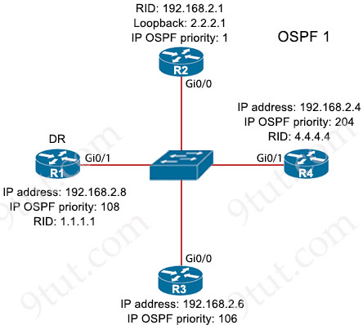
A network engineer is verifying the settings on a new OSPF network. All OSPF configurations use the default values unless otherwise indicated. Which router does the engineer expect will be elected as the DR when all devices boot up simultaneously?
A. R1
B. R2
C. R3
D. R4

Answer: D
Explanation
The router with highest OSPF priority will be elected as the DR when all devices boot up simultaneously.
Question 14.50
Refer to the exhibit.
Output from R1
GigabitEthernet0/0/1 is up, line protocol is down
Hardware is SPA—10X1GE-V2, address is 0023.33ee.7o00 (bia 0023.33ee.7c00)
MTU 1500 bytes, BW 1000000 Kbit/sec, DLY 10 usec,
reliability 255/255, txload 1/255, rxload 1/255
Encapsulation ARPA, loopback not set
Keepalive not supported
Half Duplex, 1000Mbps, link type is auto, media type is LX
output flow-control is off, input flow-control is off
ARP type: ARPA, ARP Timeout 04:00:00
Last input 00:00:01, output 00:02:31, output hang never
10 input errors, 0 CRC, 0 frame, 0 overrun, 0 ignored
0 watchdog, 314 multicast, 0 pause input
1 packets output, 77 bytes, 0 underruns
0 output errors, 50 collisions, 6 interface resets
17 unknown protocol drops
0 babbles, 0 late collision, 0 deferred
What is the issue with the interface GigabitEthernet0/0/1 ?
A. cable disconnect
B. duplex mismatch
C. port security
D. high throughput

Answer: B
Explanation
From the output, we learn that “line protocol is down” which means a Layer 2 issue. Moreover we have “50 collisions” and this interface was set to “half duplex” so we can think about “duplex mismatch” issue.
If the issue is “cable disconnect” we will see “down/down (disable)” state instead.
Question 14.51
Refer to the exhibit.
{
"interfaces":["ethernet0/3", "ethernet0/4", "ethernet0/5"]
}
Which type of JSON data is shown?
A. string
B. sequence
C. object
D. Boolean

Answer: C
Explanation
JSON syntax structure:
+ uses curly braces {} to hold objects
Question 14.52
By default, how long will the switch continue to know a workstation MAC address after the workstation stops sending traffic?
A. 200 seconds
B. 300 seconds
C. 600 seconds
D. 900 seconds

Answer: B
Explanation
The default MAC address age timeout is 300 seconds.
Question 14.53
Refer to the exhibit.
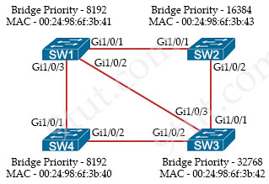
Rapid PVST+ mode is on the same VLAN on each switch. Which switch becomes the root bridge and why?
A. SW3, because its priority is the highest
B. SW2, because its MAC address is the highest
C. SW4, because its priority is highest and its MAC address is lower
D. SW1, because its priority is the lowest and its MAC address is higher

Answer: C
Explanation
“its priority is highest” means lowest value.
Question 14.54
Drag and drop the commands from the left onto the destination interfaces on the right. Not all commands are used.
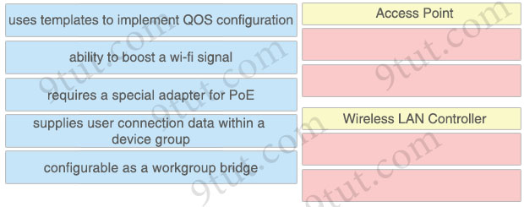

Answer:
Access Point:
+ ability to boost a wi-fi signal
+ configurable as a workgroup bridge
Wireless LAN Controller:
+ uses templates to implement QOS configuration
+ supplies user connection data within a device group
Explanation
An access point in workgroup bridge mode can introduce a bridge loop if you connect its Ethernet port to your wired LAN.
Reference: https://www.cisco.com/c/en/us/td/docs/routers/access/wireless/software/guide/RolesWGB.html
WLC can use templates to implement QoS configuration:
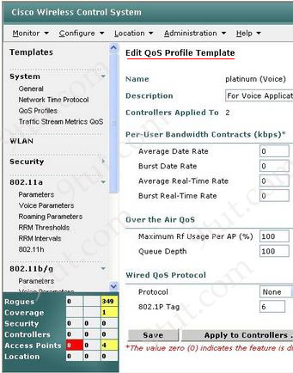
Question 14.55
Which selections must be used on the WLC when implementing a RADIUS server for wireless authentication?
A. Client Exclusion and SSH
B. Network Access Control State and SSH
C. 802.1x and the MAC address of the server
D. AAA Override and the IP address of the server

Answer: D
Explanation
The AAA Override feature on a Wireless LAN Controller (WLC) is used to override the default authentication, authorization, and accounting (AAA) settings for specific WLANs (Wireless LANs).
Typically, WLANs are configured with default AAA settings on the WLC. These settings define how clients are authenticated, authorized, and accounted for when they connect to the WLAN. With the AAA Override feature, you can override these default settings for specific WLANs. This allows you to tailor the authentication, authorization, and accounting behavior for each WLAN independently. By using AAA Override, you can apply customized AAA policies to specific WLANs based on their requirements. For example, you might want to enforce stricter authentication methods or assign different authorization roles for users connecting to a guest WLAN compared to an employee WLAN.
Note: The WLC also needs the IP address of the AAA server so that it can communicate with AAA server.
Question 14.56
How does a hub handle a frame traveling to a known destination MAC address differently than a switch?
A. The hub forwards the frame to all ports in the FIB table, and a switch forwards the frame the destination MAC is known.
B. The hub forwards the frame to all ports, and a switch forwards the frame to the known destination.
C. The hub forwards the frame using the information in the MAC table, and a switch uses data in its routing table.
D. The hub forwards the frame only to the port connected to the known MAC address,and a switch forwards the frame to all ports.

Answer: B
Question 14.57
What is the purpose of an ESSID?
A. It provides greater security than a standard SSID.
B. It supports fast roaming features such as 802.11 r, 802.11k, and 802.11v.
C. It serves as the wireless MAC address of the access point.
D. It allows multiple access points to provide a common network for client connections.

Answer: D
Explanation
A group of access points connected to the same WLAN are known as an Extended Service Set (ESS). Within an ESS, a client can associate with any one of many access points that use the same Extended service set identifier (ESSID). It allows users to roam about an office without losing wireless connection.
Question 14.58
Which port-security violation mode drops traffic from unknown MAC addresses and forwards an SNMP trap?
A. restrict
B. protect
C. shutdown VLAN
D. shutdown

Answer: A
Explanation
For your information, the port security violation modes are described below:
Protect – This mode permits traffic from known MAC addresses to continue to be forwarded while dropping traffic from unknown MAC addresses when over the allowed MAC address limit. When configured with this mode, no notification action is taken when traffic is dropped.
Restrict – This mode permits traffic from known MAC addresses to continue to be forwarded while dropping traffic from unknown MAC addresses when over the allowed MAC address limit. When configured with this mode, a syslog message is logged, a Simple Network Management Protocol (SNMP) trap is sent, and a violation counter is incremented when traffic is dropped.
Shutdown – This mode is the default violation mode; when in this mode, the switch will automatically force the switchport into an error disabled (err-disable) state when a violation occurs. While in this state, the switchport forwards no traffic. The switchport can be brought out of this error disabled state by issuing the errdisable recovery cause CLI command or by disabling and reenabling the switchport.
Shutdown VLAN -This mode mimics the behavior of the shutdown mode but limits the error disabled state the specific violating VLAN.
Reference: https://www.ciscopress.com/articles/article.asp?p=1722561
Question 14.59
Which physical component is distributed among multiple virtual machines running on the same hypervisor?
A. hardware resources
B. network interfaces
C. backplane network
D. external storage

Answer: A
Explanation
Although the VM is still dependent on the host’s physical resources, those resources are virtualized and distributed across the VMs and can be reassigned as necessary.
Reference: https://www.techtarget.com/searchitoperations/definition/virtual-machine-VM
Question 14.60
Which cable type must be used when connecting two like devices together using these criteria?
– Pins 1 to 3 and 2 to 6 are required.
– Auto detection MDI-X is unavailable.
A. straight-through
B. console
C. crossover
D. rollover

Answer: C
Explanation
Without the MDI-X auto detection feature, we have to use correct cable type to connect two devices. Two devices of the same type (like router to router, switch to switch) always use the crossover cable.
Question 14.61
PC1 tries to send traffic to newly installed PC2. The PC2 MAC address is not listed in the MAC address table of the switch, so the switch sends the packet to all ports in the same VLAN. Which switching concept does this describe?
A. MAC address aging
B. MAC address table
C. spanning-tree protocol
D. frame flooding

Answer: D
Question 14.62
Drag and drop the characteristic from the left onto the cable type on the right.
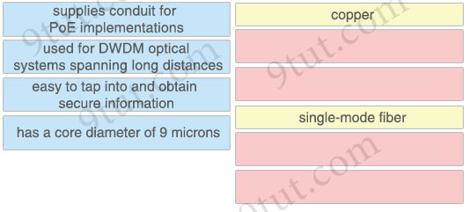

Answer:
copper:
+ supplies conduit for PoE implementations
+ easy to tap into and obtain secure information
single-mode fiber:
+ used for DWDM optical systems spanning long distances
+ has a core diameter of 9 microns
Question 14.63
Drag and drop the characteristic from the left onto the cable type on the right.
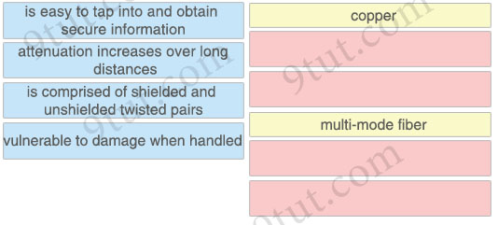

Answer:
copper:
+ is easy to tap into and obtain secure information
+ is comprised of shielded and unshielded twisted pairs
multi-mode fiber:
+ attenuation increases over long distances
+ vulnerable to damage when handled
Question 14.64
Which two tasks support the physical access control element of a security program? (Choose two)
A. Deploy a video surveillance system
B. Run a workshop on corporate security policies
C. Implement badge access to critical locations
D. Develop slideshows about new security regulations
E. Disperse information about how to protect the organization’s confidential data

Answer: A C
Explanation
Physical access control: Infrastructure locations, such as network closets and data centers, should remain securely locked. Badge access to sensitive locations is a scalable solution, offering an audit trail of identities and timestamps when access is granted. Administrators can control access on a granular basis and quickly remove access when an employee is dismissed.
Physical access control can take a number of forms, but the basic idea is to create barriers to prevent unauthorized people from entering a physical space.
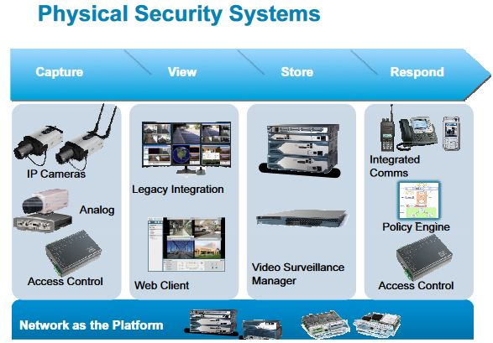
Reference: https://www.cisco.com/c/dam/global/hr_hr/assets/images/Cisco_rjesenja_za_zastitu_objekata_i_imovine_-_Alper_Erdal.pdf
Question 14.65
Drag and drop the characteristic from the left onto the cable type on the right.
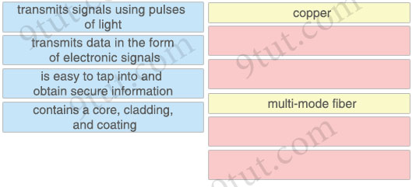

Answer:
copper:
+ transmits data in the form of electronic signals
+ is easy to tap into and obtain secure information
multi-mode fiber:
+ transmits signals using pulses of light
+ contains a core, cladding, and coating
Explanation
The two main elements of an optical fiber are its core and cladding. The “core”, or the axial part of the optical fiber made of silica glass, is the light transmission area of the fiber. It may sometimes be treated with a “doping” element to change its refractive index and therefore the velocity of light down the fiber.
The “cladding” is the layer completely surrounding the core.

Reference: https://www.cisco.com/c/en/us/products/collateral/interfaces-modules/transceiver-modules/white_paper_c11-463661.html
Question 14.66
Which interface condition is occurring in this output?
R9# show interface fa0/0
FastEthernet0/0 is up, line protocol is up
Hardware is DEC21140, address is ca02.7788.0000 (bia ca02.7788.0000)
Description: atlanta_subnet
Internet address is 10.32.102.2/30
MTU 1500 bytes, BW 100000 Kbit/sec, DLY 100 usec,
reliability 255/255, txload 1/255, rxload 1/255
Encapsulation ARPA, loopback not set
Keepalive set (60 sec)
full-duplex, 100 Mb/s, 100BaseTX/FX
ARP type: ARPA, ARP Timeout 04:00:00
Last input 00:00:01, output 00:00:00, output hang never
Last clearing of "show interface" counters 00:00:18
Input queue: 175/300/0/0 (size/max/drops/flushes); Total output drops: 100
Queueing strategy: fifo
Output queue: 50/300 (size/max)
30 second input rate 0 bits/sec, 0 packets/sec
30 second output rate 0 bits/sec, 0 packets/sec
7331 packets input, 7101162 bytes
Received 267 broadcasts (0 IP multicasts)
0 runts, 0 giants, 0 throttles
0 input errors, 0 CRC, 0 frame, 0 overrun, 0 ignored
0 watchdog
0 input packets with dribble condition detected
3927 packets output, 1440403 bytes, 0 underruns
0 output errors, 0 collisions, 0 interface resets
0 unknown protocol drops
0 babbles, 0 late collision, 0 deferred
0 lost carrier, 0 no carrier
0 output buffer failures, 0 output buffers swapped out
A. broadcast storm
B. bad NIC
C. queueing
D. duplex mismatch

Answer: C
Question 14.67
Network security team noticed that an increasing number of employees are becoming victims of phishing attacks. Which security program should be implemented to mitigate the problem?
A. user awareness training
B. email system patches
C. software firewall enabled on all PCs
D. physical access control

Answer: A
Explanation
User awareness programs are designed to make employees aware of potential security threats and risks so it is the best answer for this question. Most of phishing attacks are done online so we cannot use physical access control.
Question 14.68
How does IPsec provide secure networking for applications within an organization?
A. It leverages TFTP providing secure file transfers among peers on the network.
B. It provides GRE tunnels to transmit traffic securely between network nodes.
C. It enables sets of security associations between peers.
D. It takes advantage of FTP to secure file transfers between nodes on the network.

Answer: C
Question 14.69
Company has decided to require multifactor authentication for all systems. Which set of parameters meets the requirement?
A. personal 10-digit PIN and RSA certificate
B. complex password and personal 10-digit PIN
C. password of 8 to 15 characters and personal 12-digit PIN
D. fingerprint scanning and facial recognition

Answer: A
Explanation
Multi-factor authentication, or MFA, protects your applications by using a second source of validation before granting access to users. Common examples of multi-factor authentication include personal devices, such as a phone or token, or geographic or network locations.
Reference: https://www.cisco.com/c/en/us/products/security/what-is-multi-factor-authentication.html
MFA compose of 2 identification
*Something you have
*Something you are
*Something you know
Answer A is correct because this will give you 2 factor authentication which is something you have and something you know
Answer B is incorrect because this fall within something you know only.
Answer C is incorrect because this fall within something you know only.
Answer D is incorrect because this fall within something you have only.
Question 14.70
What should a network administrator consider when deciding to implement automation?
A. Manual changes frequently lead to configuration errors and inconsistencies.
B. Network automation typically is limited to the configuration and management of virtual devices within a network.
C. Network automation typically increases enterprise management operating costs.
D. Automated systems may have difficulty expanding network changes at scale.

Answer: A
Question 14.71
Which capability does TFTP provide?
A. loads configuration files on systems without data storage devices
B. provides secure file access within the LAN
C. provides encryption mechanisms for file transfer across a WAN
D. provides authentication for data communications over a private data network

Answer: A
Question 14.72
Refer to the exhibit.
cat9k-acc-1# show interfaces gigabitethernet 1/0/1
gigabitethernet 1/0/1 is up, line protocol is up
Hardware is gigabitethernet, address is aa00.0400.0134 (via 0000.0c00.4369)
MTU 1500 bytes, BW 1000 Kbit, DLY 1000 usec, rely 255/255, load 1/255
Encapsulation ARPA, loopback not set, keepalive set (10 sec)
ARP type: ARPA, PROBE, ARP Timeout 4:00:00
Last input 0:00:00, output 0:00:00, output hang never
Output queue 1/1, 1 drops; input queue 0/0, 0 drops
Five minute input rate 61000 bits/sec, 200 packets/sec
Five minute output rate 1000 bits/sec, 200 packets/sec
2295197 packets input, 305539992 bytes, 0 no buffer
Received 1925500 broadcasts, 0 runts, 0 giants
0 input errors, 1790 CRC, 1790 frame, 0 overrun, 0 ignored, 0 abort
0 input packets with dribble condition detected
3594664 packets output, 436549843 bytes, 1 underruns
0 output errors, 1 collisions, 1 interface resets, 0 restarts
The switch cat9k-acc-1 connects users to the campus LAN. Printing services are inaccessible through the network. Which interface issue is causing the connectivity problems?
A. A bad checksum is causing Ethernet frames to drop.
B. Excessive collisions are causing dropped frames.
C. A large number of broadcast packets are resulting in a port reset.
D. The interface output queue cannot process the Ethernet frames.

Answer: A
Explanation
There are large number of CRC errors (1790 CRC) so answer A is the best choice.
Note: CRC field in the “show interfaces …” command is the number of packets received with CRC (Cyclic Redundancy Checksum) errors. This means that the checksum that was generated by the sender does not match the checksum that the receiver calculated. On a LAN this typically occurs when you have issues with cabling or defective network cards.
Question 14.73
Which connection type is used when an engineer connects to an AP without a configured IP address or dial-up number to manage the device?
A. VIY
B. console
C. AUX
D. Ethernet

Answer: B
Question 14.74
Refer to the exhibit.
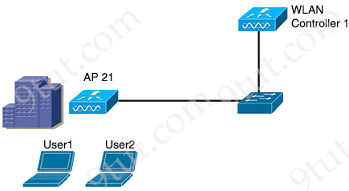
A network engineer must configure the WLC to allow only DHCP and DNS packets for User1 and User2. Which configuration must be used?
A. Enable Web Authentication for 802.1X standard in the Layer 2 Security configuration
B. Enable Fallback Policy with MAC filtering under the Layer 3 Security configuration
C. Enable Web policy and Authentication in the Layer 3 Security configuration
D. Enable Web Authentication under the AAA Server configuration on the WLAN

Answer: C
Explanation
Web Authentication or Web Auth is a layer 3 security method that allow client to pass DHCP & DNS traffic only until they have passed some form of authentication.
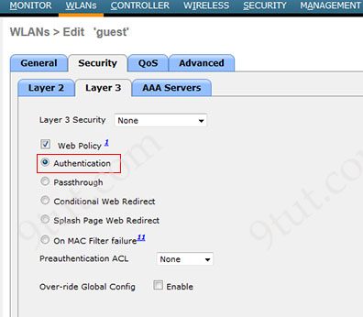
When you enable Authentication option (as shown in the above screen capture), a guest client has to enter a username & password to gain access to the guest network.
Reference: https://mrncciew.com/2013/03/21/wlc-web-authentication/
Question 14.75
Which type of wired port is required when an AP offers one unique SSID, passes client data and management traffic, and is in autonomous mode?
A. default
B. trunk
C. access
D. LAG

Answer: C
Explanation
Each SSID is mapped to one VLAN so in this question we only need one VLAN so we can assign the wired port in access mode.
Question 14.76
Refer to the exhibit.
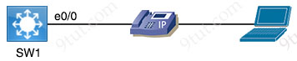
SW_1#show vlan
VLAN Name Status Ports
1 default active Et0/2,Et1/0,Et1/0,Et1/3
5 MGMT Vlan active Et1/1
6 Server Vlan active
72 Data Vlan active Et0/0
1002 fddi-default act/unsup
1003 token-ring-default act/unsup
1004 fddinet-default act/unsup
1005 trnet-default act/unsup
VoIP is being implemented in the network using VLAN ID 73 and named “VoIP”. Each user needs a Cisco IP phone at their desk. Switchport e0/0 has been configured as an access port in the data VLAN. Cisco Discovery Protocol is enabled globally. Which command sequence completed the configuration?
Option A  vlan 73  name VoIP  e0/0  switchport trunk allowed vlan 72,73  switchport voice vlan 73 | Option B  vlan 73  name VoIP  e0/0  switchport mode trunk  channel-group 73 mode active
Option C  vlan 73  name VoIP  e0/0  switchport voice vlan 73 | Option D  vlan73  name VoIP  e0/0  switchport voice vlan dot1p
A. Option A
B. Option B
C. Option C
D. Option D

Answer: C
Explanation
The voice VLAN feature enables access ports to carry IP voice traffic from an IP phone.
Question 14.77
Refer to the exhibit.
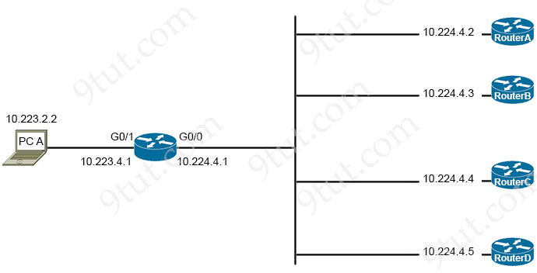
Router-Y#show ip route
Codes: L - local, C - connected, S - static, R - RIP, M - mobile, B - BGP
D - EIGRP, EX - EIGRP external, O - OSPF, IA - OSPF inter area
N1 - OSPF NSSA external type 1, N2 - OSPF NSSA external type 2
E1 - OSPF external type 1, E2 - OSPF external type 2
i - IS-IS, su - IS-IS summary, L1 - IS-IS level-1, L2 - IS-IS level-2
ia - IS-IS inter area, * - candidate default, U - per-user static route
o - ODR, P - periodic downloaded static route, H - NHRP, l - LISP
+ - replicated route, % - next hop override, p - overrides from PfR

Gateway of last resort is not set
10.0.0.0/8 is variably subnetted
S 10.0.0.0/8 [1/0] via 10.224.4.2
B 10.127.151.192/27 [20/0] via 10.224.4.3, 1w6d
S 10.128.0.0/9 [1/0] via 10.224.4.3
B 10.224.0.0/11 [20/0] via 10.224.4.5, 5d18h
B 10.224.0.0/15 [20/0] via 10.224.4.4, 5d18h
C 10.223.4.0/24 is directly connected, GigabitEthernet0/1
C 10.224.4.0/24 is directly connected, GigabitEthernet0/0
B 10.226.34.0/24 [20/0] via 10.224.4.5, 5d18h
PC A is communicating with another device at IP address 10.227.151.255.Through which router does router Y route the traffic?
A. router A
B. router B
C. router C
D. router D

Answer: D
Explanation
The destination IP address 10.227.151.255 belongs to 10.224.0.0/11 (increment: 32) and it is the longest prefix match so it will be routed via 10.224.4.5 which is router D.
Question 14.78
Refer to the exhibit.
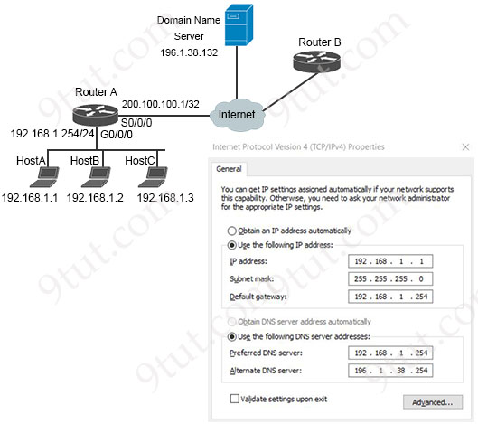
What is preventing host A from reaching the internet?
A. LAN and WAN network segments are different.
B. IP address assignment is incorrect.
C. The default gateway should be the first usable IP address.
D. The domain name server is unreachable.

Answer: D
Explanation
From the dialog in the exhibit, we see the both IP address and default gateway were configured correctly for host A. But the IP addresses of “Preferred DNS server” and “Alternate DNS server” were wrongly configured. The correct DNS server should be 196.1.38.132 (not 192.168.1.254 or 196.1.38.254).
Question 14.79
Refer to the exhibit.
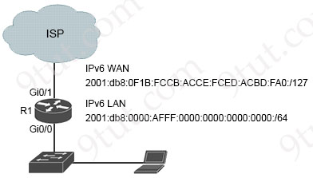
IPv6 must be implemented on R1 to the ISP. The uplink between R1 and the ISP must be configured with a manual assignment, and the LAN interface must be self-provisioned. Both connections must use the applicable IPv6 networks. Which two configurations must be applied to R1? (Choose two)
A. interface Gi0/0
ipv6 address 2001:db8:0F1B:FCCB:ACCE:FCED:ABCD:FA03:/127
B. interface Gi0/0
ipv6 address 2001:db8:0:AFFF::/64 eui-64
C. interface Gi0/0
ipv6 address 2001:db8:1:AFFF::/64 eui-64
D. interface Gi0/1
ipv6 address 2001:db8:0F1B:FCCB:ACCE:FCED:ABCD:FA02:/127
E. interface Gi0/1
ipv6 address 2001:db8:0F1B:FCCB:ACCE:FCED:ABCD:FA00:/127

Answer: B E
Explanation
We need to assign the LAN interface (gi0/0) with “eui-64” keyword and and correct IPv6 network (2001:db8:0:AFFF::/64) -> Answer B is correct.
IPv6 addresses are 128 bits long, but in this question we have /127 subnet mask. So there are only two addresses:
2001:db8:0F1B:FCCB:ACCE:FCED:ABCD:FA00 (Network Address)
2001:db8:0F1B:FCCB:ACCE:FCED:ABCD:FA01 (Usable Host Address)
-> Therefore surely answer D is not correct as it is out-of-range of this network. Some devices may support /127 subnet mask and we can assign both above addresses for (point-to-point) devices.
Note: In IPv6, there is no concept of a broadcast address as in IPv4. Instead, IPv6 uses multicast addresses for similar purposes.
Question 14.80
Refer to the exhibit.
configure terminal
interface range GigabitEthernet 0/1-2
switchport mode trunk
channel-group 1 mode active

SW2
configure terminal
interface range GigabitEthernet 0/1-2
switchport mode trunk
interface Port-channel1
switchport mode trunk
An LACP EtherChannel between two directly connected switches is in the configuration process. Which command must be configured on switch SW2s Gi0/1-2 interfaces to establish the channel to SW1?
A. channel-group 1 mode desirable
B. channel-group 1 mode on
C. channel-group 1 mode active
D. channel-group 1 mode auto

Answer: C
Question 14.81
An on-site service desk technician must verify the IP address and DNS server information on a user’s Windows computer. Which command must the technician enter at the command prompt on the user’s computer?
A. ipconfig /all
B. show interface
C. netstat -r
D. ifconfig -a

Answer: A
Question 14.82
What are two functions of DHCP servers? (Choose two)
A. support centralized IP management
B. issue DHCPDISCOVER messages when added to the network
C. respond to client DHCPOFFER requests by Issuing an IP address
D. prevent users from assigning their own IP addresses to hosts
E. assign dynamic IP configurations to hosts in a network

Answer: A E
Explanation
Benefits of DHCP
Centralized IP Address Management: DHCP centralizes the management of IP address allocation and configuration parameters for switches. Administrators can configure and control IP address assignment policies, lease durations, and other network parameters from a central DHCP server, ensuring consistency and simplifying network administration for switches.
Reference: https://www.versitron.com/blogs/post/the-role-of-dhcp-in-efficient-ip-address-management
Question 14.83
Which SNMP message type is reliable and precedes an acknowledgment response from the SNMP manager?
A. Inform
B. Get
C. Traps
D. Set

Answer: A
Explanation
From SNMPv2c, two new messages were added: INFORM and GETBULK.
INFORM: An disadvantage of TRAP message is unreliable. SNMP communicates via UDP so it is unreliable because when the SNMP Agents send TRAP message to the SNMP Manager it cannot know if its messages arrive to the SNMP Manager. To amend this problem, a new type of message, called INFORM, was introduced from SNMPv2. With INFORM message, the SNMP Manager can now acknowledge that the message has been received at its end with an SNMP response protocol data unit (PDU). If the sender never receives a response, the INFORM can be sent again. Thus, INFORMs are more likely to reach their intended destination.
Question 14.84
When more than one AP-Manager interface is provisioned on a wireless LAN controller, how is the request handled by the AP?
A. The discovery response from the AP to the AP-Manager interface disables the WLAN port
B. The AP join request fails and must be configured statically on the AP-Manager interface
C. The first AP-Manager interface to respond is chosen by the AP
D. The AP-Manager with the fewest number of APs is used by the AP to join

Answer: D
Explanation
Before an access point joins a controller, it sends out a discovery request. From the discovery response that it receives, the access point can tell the number of AP-manager interfaces on the controller and the number of access points on each AP-manager interface. The access point generally joins the AP-manager with the least number of access points. In this way, the access point load is dynamically distributed across the multiple AP-manager interfaces.
Reference: https://www.cisco.com/c/en/us/td/docs/wireless/controller/7-4/configuration/guides/consolidated/b_cg74_CONSOLIDATED/m_configuring_multiple_ap_manager_interfaces.pdf
Question 14.85
What is a service that is provided by a wireless controller?
A. It issues IP addresses to wired devices.
B. It manages interference in a dense network.
C. It provides Layer 3 routing between wired and wireless devices.
D. It mitigates threats from the internet.

Answer: B
Explanation
Answer A is not correct as it is the function of a DHCP server.
Answer C is not correct as wireless devices usually do not need Layer 3 routing and this is not a function of a WLC.
WLC can mitigate threats from rogue APs but not from the Internet -> Answer D is not correct.
Answer B is correct as WLC can manage interference via RRM:
“The Radio Resource Management (RRM) software embedded in the Cisco Wireless Controller acts as a built-in RF engineer to consistently provide real-time RF management of your wireless network. RRM enables controllers to continually monitor their associated lightweight access points for the following information:
Traffic load: The total bandwidth used for transmitting and receiving traffic. It enables wireless LAN managers to track and plan network growth ahead of client demand.
Interference: The amount of traffic coming from other 802.11 sources.
…
Using this information, RRM can periodically reconfigure the 802.11 RF network for best efficiency.”
Reference: https://www.cisco.com/c/en/us/td/docs/wireless/controller/8-5/config-guide/b_cg85/radio_resource_management.html
Question 14.86
Drag and drop the HTTP verbs from the left onto the API operations on the right.
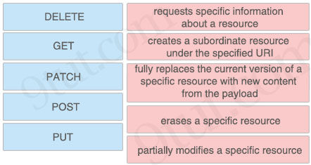

Answer:
+ DELETE: erases a specific resource
+ GET: requests specific information about a resource
+ PATCH: partially modifies a specific resource
+ POST: creates a subordinate resource under the specified URI
+ PUT: fully replaces the current version of a specific resource with new content from the payload
Explanation
GET: retrieve data
POST: create data
PUT: fully update (i.e. replace) an existing record
PATCH: update part of an existing record
DELETE: delete records
PUT is similar to POST in that it can create resources, but it does so when there is a defined URL wherein PUT replaces the entire resource if it exists or creates new if it does not exist.
Unlike PUT Request, PATCH does partial update. Fields that need to be updated by the client, only that field is updated without modifying the other field.
Question 14.87
Refer to the exhibit.
wireless LAN adapter Wi-Fi

Connection-specific DNS Suffix
Description .......... : Intel(R) dual Band wireless-AC 7265
Physical Address........ : C8-21-5B-B4-D3-E0
DHCP Enabled.......... : YES
Autoconfiguration Enabled . . .: YES
Link-local IPv6 Address . . . .: fe80::45a1:b3fa:2f37:bf37%2(Preferred)
IPv4 Address.......... : 192.168.25.103((Preferred)
Subnet Mask.......... : 255.255.255.0
Lease Obtained......... : June 11, 2019 10:21:31 AM
Lease Expires ......... : June 12, 2019 10:21:36 AM
Default Gateway ........ : 192.168.25.1
DHCP Server .......... : 192.168.25.100
DHCPV6 IAID.......... : 46670168
DHCPv6 Client DUID....... : 00-01-00-20-FF-05-55-3C-52-82-33-D3-84
DNS Servers .......... : 192.168.25.254
192.168.25.254
Which address will the client contact to renew their IP address when the current lease expires?
A. 192.168.25.103
B. 192.168.25.100
C. 192.168.25.1
D. 192.168.25.254

Answer: B
Explanation
The client will contact DHCP server again to renew their expired IP address.
Question 14.88
Refer to the exhibit.
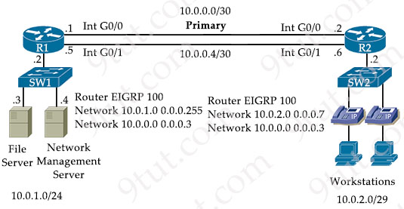
A secondary route is required on router R1 to pass traffic to the LAN network on R2 if the primary link fails. Which command must be entered to configure the router?
A. ip route 10.0.2.0 256.255.255.248 null0 93
B. ip route 10.0.2.0 255.255.255.240 10.0.0.6 91
C. ip route 10.0.2.0 255.255.255.240 10.0.0.7 92
D. ip route 10.0.2.0 255.255.255.248 10.0.0.6 91

Answer: D
Explanation
We need to add a floating static route in this case so this route must have the AD greater than the AD of EIGRP (90) to the next-hop of 10.0.0.6 (R2) for 10.0.2.0/29 (with subnet mask of 255.255.255.248).
Question 14.89
Drag and drop the IPv6 address type characteristics from the left to the right.
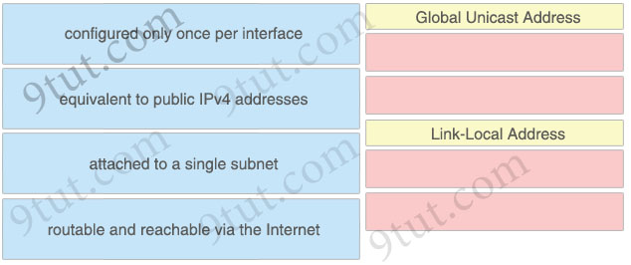

Answer:
Global Unicast Address:
+ equivalent to public IPv4 addresses
+ routable and reachable via the Internet
Link-Local Address:
+ configured only once per interface
+ attached to a single subnet
Question 14.90
Refer to the exhibit .
{
"Cisco Devices": [
{
"name": "ASA - Security Device",
"name": "Cisco 1100 ASR Router",
"name": "Cisco 6800 Switch"
}
]
What is missing from this output for it to be executed?
A. square bracket ( [ ) at the beginning
B. curly brace ( } ) at the end
C. double quotes (” “) around the “Cisco Devices” string
D. exclamation point (!) at the beginning of each line

Answer: B
Question 14.91
Refer to the exhibit.
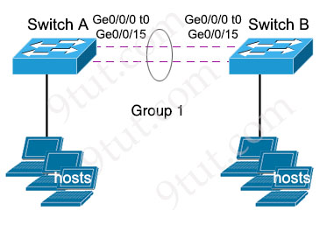
The LACP EtherChannel is configured, and the last change is to modify the interfaces on SwitchA to respond to packets received, but not to initiate negotiation. The interface range gigabitethernet0/0/0-15 command is entered. What must be configured next?
A. SwitchA(config-if-range)#channel-group 1 mode desirable
B. SwitchA(config-if-range)#channel-group 1 mode passive
C. SwitchA(config-if-range)#channel-group 1 mode auto
D. SwitchA(config-if-range)#channel-group 1 mode active

Answer: B
Question 14.92
What are two benefits for using private IPv4 addressing? (Choose two)
A. They supply redundancy in the case of failure
B. They alleviate the shortage of public IPv4 addresses.
C. They provide a layer of security from Internet threats.
D. They offer Internet connectivity to endpoints on private networks
E. They allow for Internet access from IoT devices

Answer: B C
Question 14.93
Which EtherChannel mode must be configured when using LAG on a WLC?
A. On
B. active
C. auto
D. passive

Answer: A
Explanation
Link aggregation (LAG) is a partial implementation of the 802.3ad port aggregation standard. It bundles all of the controller’s distribution system ports into a single 802.3ad port channel.
Restriction for Link aggregation:
+ LAG requires the EtherChannel to be configured for ‘mode on’ on both the controller and the Catalyst switch.
…
Reference: https://www.cisco.com/c/en/us/td/docs/wireless/controller/7-5/configuration-guide/b_cg75/b_cg75_chapter_0100010.html
Question 14.94
Refer to the exhibit.
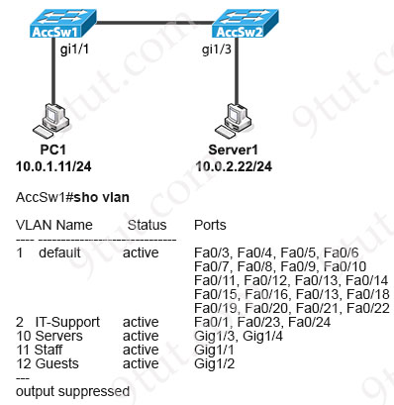
The engineer configured the VLANs on the new AccSw2 switch. A router on-a-stick is connected to both switches. How must the ports be configured on AccSw2 to establish full connectivity between the two switches and for Server1?
Option A  interface GigabitEthernet1/3  switchport mode access  switchport access vlan 10  !  interface GigabitEthernet1/24  switchport mode trunk  switchport trunk allowed vlan 2,10 | Option B  interface GigabitEthernet1/3  switchport mode access  switchport access vlan 10  !  interface GigabitEthernet1/24  switchport mode trunk
Option C  interface GigabitEthernet1/1  switchport mode access  switchport access vlan 11  !  interface GigabitEthernet1/24  switchport mode trunk | Option D  interface GigabitEthernet1/1  switchport access vlan 11  !  interface GigabitEthernet1/24  switchport mode trunk  switchport trunk allowed vlan 10,11
A. Option A
B. Option B
C. Option C
D. Option D

Answer: B
Question 14.95
A network administrator is evaluating network security in the aftermath of an attempted ARP spoofing attack. If Port-channel1 is the uplink interface of the access-layer switch toward the distribution-layer switch, which two configurations must the administrator configure on the access-layer switch to provide adequate protection? (Choose two)
Option A  ip dhcp snooping  !  interface Port-channel1  switchport port-security maximum 1  switchport port-security | Option B  ip dhcp snooping vlan 1-4094  ip dhcp snooping  !  interface Port-channel1  ip dhcp snooping trust
Option C  ip dhcp snooping vlan 1-4094  !  interface Port-channel1  switchport protected  switchport port-security maximum 1 | Option D  ip arp inspection trust  !  interface Port-channel1  switchport port-security maximum 4094  switchport port-security  ip verify source mac-check
Option E
ip arp inspection vlan 1-4094
!
interface Port-channel1
ip arp inspection trust
A. Option A
B. Option B
C. Option C
D. Option D
E. Option E

Answer: B E
Explanation
We need to configure the uplink (Po1) to the distribution switch in “trust” state.
Question 14.96
What is the maximum number of concurrent Telnet sessions that a Cisco WLC supports?
A. 3
B. 5
C. 6
D. 15

Answer: B
Explanation
From the Maximum Number of Sessions drop-down list, choose the number of simultaneous Telnet or SSH sessions allowed. The valid range is 0 to 5 sessions (inclusive), and the default value is 5 sessions.
Reference: https://www.cisco.com/c/en/us/td/docs/wireless/controller/8-1/configuration-guide/b_cg81/b_cg81_chapter_011.html
Question 14.97
What are two functions of a firewall within an enterprise? (Choose two)
A. It serves as an endpoint for a site-to-site VPN in standalone mode.
B. It enables traffic filtering based on URLs.
C. It provides support as an endpoint for a remote access VPN in multiple context mode.
D. It offers Layer 2 services between hosts.
E. It enables wireless devices to connect to the network.

Answer: B C
Question 14.98
How does Chef configuration management enforce a required device configuration?
A. The installed agent on the device connects to the Chef Infra Server and pulls its required configuration from the cookbook.
B. The Chef Infra Server uses its configured cookbook to push the required configuration to the remote device requesting updates.
C. The Chef Infra Server uses its configured cookbook to alert each remote device when it is time for the device to pull a new configuration.
D. The installed agent on the device queries the Chef Infra Server and the server responds by pushing the configuration from the cookbook.

Answer: A
Explanation
Any changes made to your infrastructure code must pass through the Chef server in order to be applied to nodes. Prior to accepting or pushing changes, the Chef server authenticates all communication via its REST API using public key encryption.
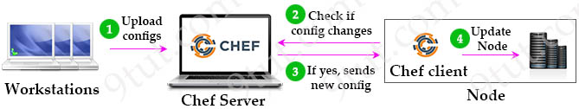
Chef client periodically pulls Chef server to see if there are any changes in cookbooks or settings. If there are changes then Chef server sends the latest configuration information to Chef client. Chef client applies these changes to nodes.
Question 14.99
What is an Ansible inventory?
A. collection of actions to perform on target devices, expressed in YAML format
B. unit of Python code to be executed within Ansible
C. device with Ansible installed that manages target devices
D. file that defines the target devices upon which commands and tasks are executed

Answer: D
Explanation
Once Ansible is installed, it creates several text files:
+ Playbooks: These files provide actions and logic about what Ansible should do. Ansible playbooks are files that contain tasks to configure hosts. Ansible playbooks are written in YAML format.
+ Inventory: a file contains a list of the hosts (usually their IP addresses, ports) which you want to configure or manage. Hosts in an inventory can be divided into smaller groups for easier management and configuration. Each group can run different tasks. An example of a task is to ping all hosts in group [routers].
+ Templates: Using Jinja2 language, the templates represent a device’s configuration but with variables.
+ Variables: Using YAML, a file can list variables that Ansible will substitute into templates.
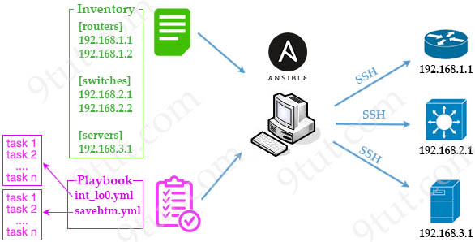
Question 14.100
Which two host addresses are reserved for private use within an enterprise network? (Choose two)
A. 10.172.76.200
B. 12.17.1.20
C. 172.15.2.250
D. 192.169.32.10
E. 172.31.255.100

Answer: A E
Explanation
The following IPv4 address ranges are reserved by the IANA for private internets, and are not publicly routable on the global internet:
+ 10.0.0.0/8 IP addresses: 10.0.0.0 – 10.255.255.255 -> Answer A is correct.
+ 172.16.0.0/12 IP addresses: 172.16.0.0 – 172.31.255.255 -> Answer E is correct.
+ 192.168.0.0/16 IP addresses: 192.168.0.0 – 192.168.255.255
Question 14.101
What is the recommended switch load-balancing mode for Cisco WLCs?
A. source-destination MAC address
B. destination IP address
C. destination MAC address
D. source-destination IP address

Answer: D
Question 14.102
Refer to the exhibit.
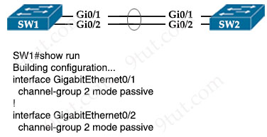
Which configuration enables SW2 to establish an LACP EtherChannel?
Option A  SW2(config)#interface gigabitEthernet0/1  SW2(config-if)#channel-group 2 mode desirable  SW2(config-if)#interface gigabitEthernet0/2  SW2(config-if)#channel-group 2 mode desirable | Option B  SW2(config)#interface gigabitEthernet0/1  SW2(config-if)#channel-group 1 mode active  SW2(config-if)#interface gigabitEthernet0/2  SW2(config-if)#channel-group 1 mode active
Option C  SW2(config)#interface gigabitEthernet0/1  SW2(config-if)#channel-group 1 mode on  SW2(config-if)#interface glgabitEthernet0/2  SW2(config-if)#channel-group 1 mode on | Option D  SW2(config interface gigabitEthernet0/1  SW2(config-if)#channel-group 2 mode auto  SW2(config-if)#interface gigabitEthernet0/2  SW2(config-if)#channel-group 2 mode auto
A. Option A
B. Option B
C. Option C
D. Option D

Answer: B
Explanation
The Etherchannel group numbers are only locally significant and can be different on two ends.
Question 14.103
What is a function of FTP?
A. relies on the well-known UDP port 69 for data transfer
B. uses block numbers to identify and mitigate data-transfer errors
C. uses two separate connections for control and data traffic
D. always operates without user connection validation

Answer: C
Explanation
FTP communicates using two TCP connections. Control traffic is exchanged over TCP port 21, and data transmission is performed over TCP port 20.
Question 14.104
Refer to the exhibit.
R1#show ip route
Codes: C - connected, S - static, R - RIP, M - mobile, B - BGP
D - EIGRP, EX - EIGRP external, O - OSPF, IA - OSPF inter area
N1 - OSPF NSSA external type 1, N2 - OSPF NSSA external type 2
E1 - OSPF external type 1, E2 - OSPF external type 2
i - IS-IS, su - IS-IS summary, L1 - IS-IS level-1, L2 - IS-IS level-2
ia - IS-IS inter area, * - candidate default, U - per-user static route
o - ODR, P - periodic downloaded static route
Gateway of last resort is 192.168.30.10 to network 0.0.0.0
192.168.30.0/29 is subnetted, 2 subnets
C 192.168.30.0 is directly connected, FastEthernet0/0
C 192.168.30.8 is directly connected, Serial0/0.1
192.168.10.0/24 is variably subnetted, 2 subnets, 2 masks
O IA 192.168.10.32/28 [110/193] via 192.168.30.10, 00:18:49, Serial0/0.1
O IA 192.168.10.0/27 [110/192] via 192.168.30.10, 00:18:49, Serial0/0.1
192.168.20.0/30 is subnetted, 1 subnets
O IA 192.168.20.0 [110/128] via 192.168.30.10, 00:18:49, Serial0/0.1
192.168.50.0/32 is subnetted, 1 subnets
C 192.168.50.1 is directly connected, Loopback0
O*IA 0.0.0.0/0 [110/84] via 192.168.30.10, 00:10:36, Serial0/0.1
What is the metric for the route to the 192.168.10.33 host?
A. 84
B. 110
C. 192
D. 193

Answer: D
Explanation
Traffic destined to host 192.168.10.33 will match the entry “O IA 192.168.10.32/28 [110/193] via 192.168.30.10, 00:18:49, Serial0/0.1″ so the metric is the second parameter in the square bracket.
Question 14.105
Which two statements distinguish authentication from accounting? (Choose two)
A. Only authentication challenges users for their credentials and returns a response.
B. Only authentication supports user-activity audits.
C. Only authentication validates “who you are.”
D. Only authentication records the duration of a user’s connection.
E. Only authentication provides supporting information for billing users.

Answer: A C
Question 14.106
Which set of methods is supported with the REST API?
A. GET, PUT, ERASE, CHANGE
B. GET, POST, ERASE, CHANGE
C. GET, POST, MOD, ERASE
D. GET, PUT, POST, DELETE

Answer: D

